Project Development Phase
Model Performance Test

Date | 10 February 2025
Team ID | LTVIP2026TMIDS82253
Project Name | Deep Learning Fundus Image Analysis for Early Detection of Diabetic Retinopathy
Maximum Marks

Model Performance Testing:
Project team shall fill the following information in model performance testing template.
S.No. | Parameter | Screenshot / Values
 | Data Rendered | 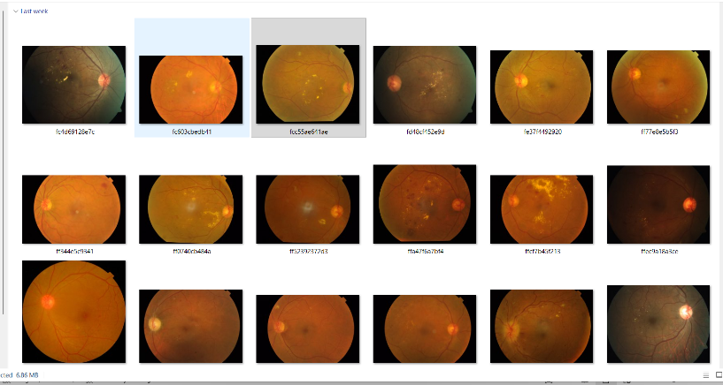4000+ images used of retinal eye images
 | Data Preprocessing | 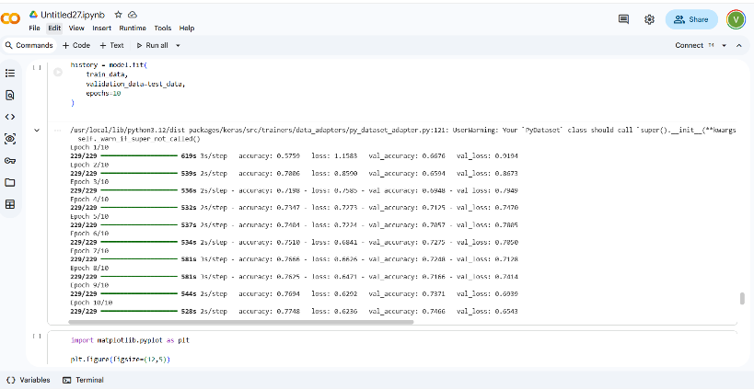
3. | Utilization of Data Filters | 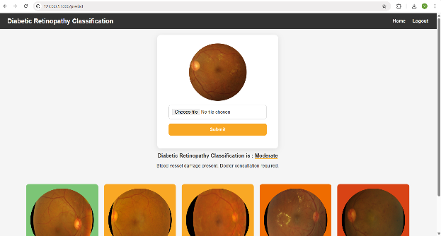
4. | DAX Queries Used | - Total number of images analyzed  - Percentage of DR-positive cases  - Accuracy trends over time
5. | Dashboard design | No of Visualizations / Graphs –  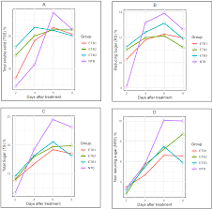
6 | Report Design | No of Visualizations / Graphs –  